Ideation Phase
Define the Problem Statements

Date | 20 June 2025
Team ID | LTVIP2025TMID42366
Project Name | BookNest
Maximum Marks | 2 Marks

Customer Problem Statement Template:
Create a problem statement to understand your customer's point of view. The Customer Problem Statement template helps you focus on what matters to create experiences people will love.
A well-articulated customer problem statement allows you and your team to find the ideal solution for the challenges your customers face. Throughout the process, you’ll also be able to empathize with your customers, which helps you better understand how they perceive your product or service.
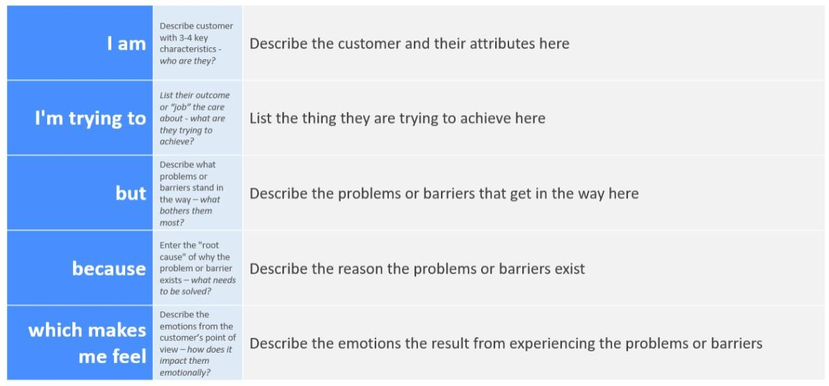
Reference: https://miro.com/templates/customer-problem-statement/ Example:
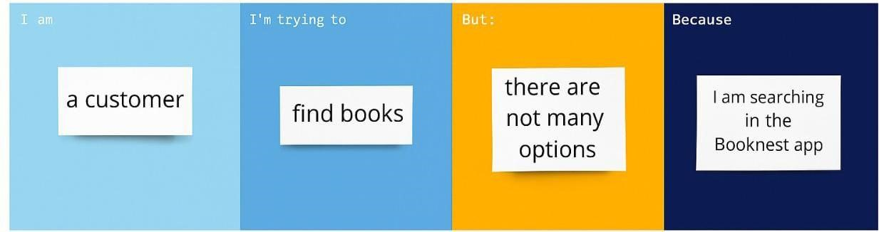
Problem Statement  (PS) | I am  (Customer) | I’m trying to | But | Because | Which makes me  feel
PS-1 | A frequent reader | Find new book recommenda  tions based on my  interests | I Keep seeing the same suggestion  s | The  recommend  ation system  isn’t  personalized | Bored and unengaged
PS-2 | A student looking for academic books | Search and filter books by subject and author | The filters don’t work well on mobile | The interface is not optimized for small screens | Frustrated and discouraged

